`NBIS SYSTEM deployment - US Government

OVERVIEW
The National Background Investigation Services (NBIS) System is the Federal Government’s one-stop-shop IT system for end-to-end personnel vetting — from initiation and application to background investigation (BI), adjudication, and continuous vetting. NBIS is a consolidated system designed to deliver robust data protection, enhance customer experience, and better integrate data across the enterprise.
The NBIS Planning and Deployment Office will work to deliver the BI initiation capability, as well as investigation, adjudication, case management features for all applicable US Government organizations.
To deliver personnel vetting capabilities and features to US Government organizations in the most efficient and transparent manner possible, the NBIS deployment support team have developed an execution plan to detail NBIS capabilities, scheduled capability delivery dates, roles and responsibilities, and actions necessary to initially onboard organizations to NBIS and to deliver any optional shared services (e.g., investigation, adjudication, subject management).
SECTION | DESCRIPTION
NBIS SYTEM CAPABILITIES & FEATURES | Overview of the features and capabilities available on the NBIS System
DELIVERING NBIS CAPABILITIES AND FEATURES | Overview of how the NBIS System will be deployed to Government organizations
NBIS ONBOARDING | Overview of the NBIS onboarding process and a description of the capabilities delivered to onboarded organizations
ONBOARDING - KEY PERSONNEL & ACTIONS | Overview of the key actions accomplished by personnel supporting onboarding tasks
SHARED SERVICES & OPTIONAL FEATURES | Overview of the NBIS Shared Services and the process to request and deliver those features and capabilities to organizations
SHARED SERVICES - KEY PERSONNEL & ACTIONS | Overview of the key actions accomplished by personnel supporting the delivery of a Shared Service.

NBIS System capabilities & features
NBIS will replace a suite of legacy BI and case management IT systems from the Office of Personnel Management and the Defense Manpower Data Center, including Electronic Questionnaires for Investigations Processing, Secure Web Fingerprint Transmission, Joint Personnel Adjudication System, Defense Information System for Security, Position Designation Tool, Personnel Investigations Processing System, and more.
NBIS consolidates federal personnel vetting activities into a single centralized system. As such, NBIS allows security managers, investigators, and adjudicators to access case status throughout the lifecycle of the vetting process; enhancing capacity and creating synergies from easier data validation.
The following is a listing of the major NBIS capabilities and features which will be available for delivery to Government organizations:
- BI initiation
- Subject management
- Investigative service provider (ISP) BI management
- Adjudication management
- Continuous vetting
- Appeals boards
- NBIS read-only view (for review of personnel eligibility, clearance, & incident data)
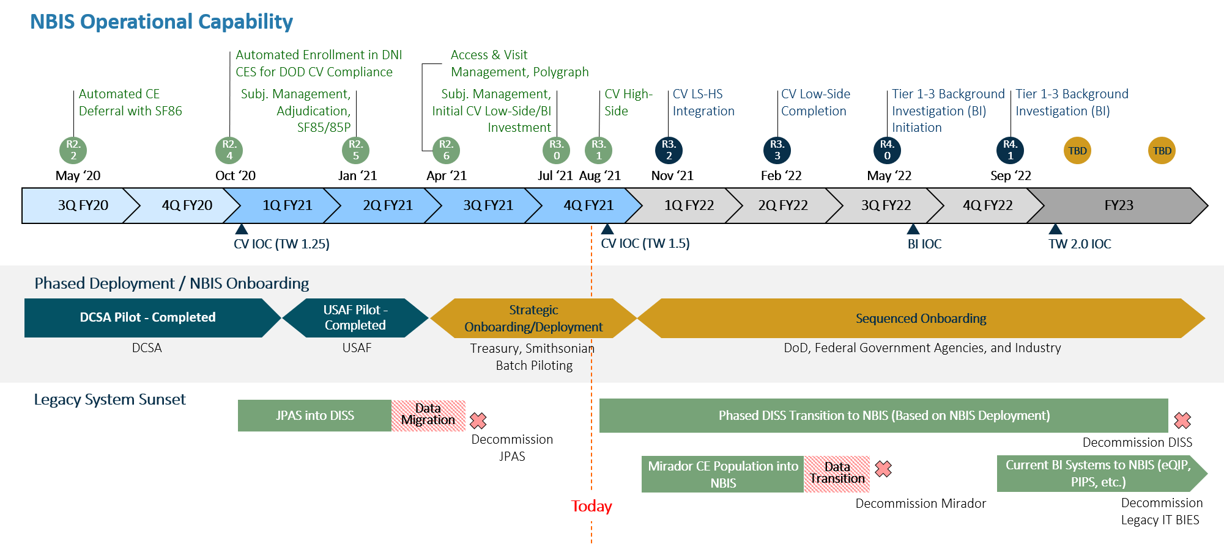
NBIS is actively developing and deploying new capabilities and features as well as enhancing its current features. Below is a tentative schedule of when major capabilities will be available in NBIS:

Delivering NBIS capabilities and features

NBIS Onboarding
All Government organizations are scheduled to onboard into NBIS between Q4FY21 and Q1FY23. During the onboarding phase, a NBIS System account will be established for each organization which requires access to current or future NBIS features or capabilities in support of their personnel vetting operations. Once onboard, an organization will be able to accomplish subject management tasks and use NBIS to initiate, review, and/or authorize the release of BIs to the applicable ISP. If additional NBIS capabilities are required, a request to deliver those features would need to be made through the DCSA’s Shared Services team.

key personnel for onboarding
  - DCSA Agency Liaison (AL) –The AL will serve as the primary point of contact for coordinating NBIS onboarding pre-requisites, providing an overview of the onboarding process, and answering or directing any questions to the appropriate NBIS teams. The AL will accomplish the following for its assigned organizations:
    - Notify the organization of its scheduled onboarding date.
    - Notify the organization of onboarding pre-requisite actions and any required documentation.
    - Provide a timely and detailed response to all Government organization questions pertaining to the onboarding process or its requirements.
    - Assist the organization in completing all pre-requisite actions within the recommended timeframes.
    - Notify the NBIS Program and Deployment Office if pre-requisites are not completed on time.
    - Inform the Deployment Onboarding Team (DOT) when the organization completes all pre-requisite activities.
  - DCSA DOT – The DOT will work with the organization to accomplish all onboarding tasks ensuring the organization has the ability to initiate, review, and/or authorize BI submissions to the applicable ISP. The DOT will accomplish the following in support of onboarding organizations to the BI initiation capability:
    - Appoint a DOT lead that ensures the onboarding objectives and approved schedule are met.
    - Host a kick-off meeting that provides an overview of the onboarding objectives, organization tasks, DOT tasks, and the onboarding activities schedule and estimated completion date.
    - Work with the organization to finalize the NBIS hierarchy, form routing paths, and framework needed to accomplish BI initiation activities.
    - Train the organization’s appointed Agency Deployment Team (ADT) on the basic functions of NBIS and the processes/actions required for BI initiation.
    - Close out the organization’s onboarding activities.
    - Inform the DCSA Quick Response Force (QRF) if any additional follow-up is needed.
    - Inform the DCSA Fulfillment Team if the organization requires additional NBIS capabilities (e.g. BI management, adjudication management, continuous vetting, etc.).
  - DCSA QRF – The QRF will assist organizations with developing a scaling plan. The scaling plan details how an organization intends to expand its NBIS presence and use of NBIS to the rest of the organization.
    - During the onboarding phase, meet with the Agency Deployment Team (ADT) to establish a scaling plan.
    - Respond to questions and provide guidance to organizations that are implementing their scaling plan.
    - Provide reach-back assistance to organizations as needed.
  - ADT - The Agency Onboarding Champion, with authorization from the onboarding organization, will form an ADT. The ADT, with training, guidance, and support from DCSA, will establish the organization’s hierarchy and workflow in NBIS as well as provision additional NBIS users.
    - Complete the organization’s onboarding pre-requisites and checklist and send to the respective AL.
    - Identify all NBIS capability requirements.
    - Obtain NBIS onboarding training to ensure the onboarding organization has the ability to accomplish all BI initiation tasks.
    - Conduct internal training within the organization.
    - Expands the use of NBIS throughout the organization in accordance with scaling targets.
    - Coordinates with the QRF as needed for additional DCSA support.
    - Coordinates with the DCSA Fulfillment Team if the organization requires additional NBIS capabilities (e.g. BI management, adjudication management, continuous vetting, etc.).

NBIS shared services & optional capabilities
In addition to the BI initiation capability, NBIS has a wide range of personnel security vetting services available to Government organizations. Once a Government organization has completed its BI initiation onboarding, an organization can opt-into these shared services. The following is a list of some of the available shared services which an organization can choose to add to its NBIS System account:
- ISP BI management
- Adjudication management
- Continuous vetting
- Appeals boards

key personnel for shared services
  - AL – The AL will serve as the primary point of contact for coordinating any NBIS optional shared services pre-requisite submissions and can advise the organization of any new NBIS features as they become available. The AL will accomplish the following for its assigned organizations:
    - Keep the organization abreast of the catalog of NBIS shared services and the dates which capabilities will be available for use on the system.
    - Provide the pre-requisite requirements for shared services which are of interest to the organization.
    - Coordinate and oversee an organization’s completion of all pre-requisite actions for delivering the shared services which were requested by the organization.
    - Notify the DCSA Fulfillment Team of the shared services which the organization would like delivered.
  - DCSA Fulfillment Team – The DCSA Fulfillment Team will work with the organization to ensure all requested NBIS shared services are delivered as expected. The DCSA Fulfillment Team will accomplish the following in support of delivering the organization any requested shared services capability:
    - Appoint a DCSA Fulfillment Team lead that ensures the shared services adoption objectives and approved schedule are met.
    - Host a kick-off meeting that provides an overview of the activities which will be accomplished in support of delivering the shared services and the estimated delivery date.
    - Work with the organization to ensure its selected representatives are knowledgeable of the features and capabilities of the shared services it requested as well as how to use each feature.
    - Close out the organization’s shared services adoption activities.
    - Inform the DCSA QRF if any additional follow-up is needed.

